**Image Generation using stable diffusion & Comfy UI**

A Project Report

submitted in partial fulfillment of the requirements

of

AICTE Internship on AI: Transformative Learning

with

TechSaksham – A joint CSR initiative of Microsoft & SAP

by

**Name : S MOHAMMED ARIF**

**Email id : smohammedarifarif3@gmail.com**

Under the Guidance of

**Jay Rathod**

**ACKNOWLEDGEMENT**

I extend my heartfelt gratitude to everyone who supported and guided me throughout this project.

First and foremost, I sincerely appreciate **Mr. Jay Rathod** for his invaluable mentorship in AI and Machine Learning. His expertise, particularly in model building, provided me with a strong foundation in stable diffusion models. His continuous feedback and encouragement played a crucial role in shaping this project.

I am also deeply grateful to **Adharsh P Sir** for his insightful teachings in Data Science and Statistics. His theoretical guidance significantly contributed to my understanding, helping me establish a solid base for developing the stable diffusion model.

A special thanks to **Pavan Kumar Sumohana**, whose organizational efforts streamlined the entire process. His dedication to sharing online resources and keeping me informed about project updates was instrumental in my learning journey.

Lastly, I would like to express my appreciation to the **TechSaksham initiative by Microsoft and SAP** for providing this incredible learning and training platform, which has been a significant stepping stone in my AI journey.

#### **ABSTRACT**

.

**AI-Driven Image Generation Using Stable Diffusion & ComfyUI**

This report presents the development of an AI-powered **Image Generation System** utilizing **Stable Diffusion and ComfyUI** to create high-quality, realistic images based on user inputs. Traditional image creation methods often require extensive manual effort and expertise, making them time-consuming and inaccessible to those without advanced design skills. To address these challenges, this project leverages state-of-the-art deep learning models to automate and enhance the creative process.

The system offers key functionalities such as **text-to-image generation, image refinement, and parameter customization**, providing users with an intuitive and interactive experience. Built on **ComfyUI**, the solution ensures flexibility and ease of use, allowing both beginners and professionals to experiment with AI-driven art effortlessly.

This project also explores the challenges associated with AI-generated images, including **content accuracy, ethical considerations, and computational requirements**. Experimental evaluations highlight the system’s efficiency in producing high-quality images while maintaining user control over artistic elements. Future enhancements will focus on **optimizing model performance, expanding creative capabilities, and integrating cloud-based processing** for improved accessibility and scalability.

This report outlines the methodology, implementation, and potential impact of this system, showcasing its ability to revolutionize digital content creation and simplify complex design workflows.

**TABLE OF CONTENT**

**Abstract I**

**Chapter 1.**  **Introduction 1**

1.1 Problem Statement 1

1.2 Motivation 1

1.3 Objectives 2

1.4. Scope of the Project 2

**Chapter 2.**  **Literature Survey 3**

**Chapter 3.**  **Proposed Methodology**

**Chapter 4.**  **Implementation and Results**

**Chapter 5. Discussion and Conclusion**

**References**

**LIST OF FIGURES**

|  |  |  |
| --- | --- | --- |
| **Figure No.** | **Figure Caption** | **Page No.** |
|  | Sunset Over the Ocean | **13** |
|  | Robot Holding a Book | **14** |
|  | Cute Puppy Playing | **14** |
|  | Space Explorer on Mars | **15** |

**Chapter 1:**

**Introduction**

**1.1 Problem Statement**

Comfy UI is an open-source framework designed to create user-friendly interfaces for Stable Diffusion and similar AI tools. Stable Diffusion is a deep learning model that generates images based on text prompts, offering immense creative possibilities. However, interacting with this powerful tool often requires technical know-how, which can be a challenge for many users.

**The Challenge:**

Building an intuitive and seamless user interface that makes image generation with Stable Diffusion accessible to everyone, regardless of their technical background.

**The Objective:**

Our goal is to develop a user-friendly interface using Comfy UI that enables effortless interaction with the Stable Diffusion model. This interface should cater to both beginners and professionals, allowing them to create high-quality custom images from text prompts with ease. Whether for concept art, visual design, or creative exploration, the UI should enhance accessibility and usability while retaining advanced customization options.

**Why This Matters:**

Despite Stable Diffusion’s impressive capabilities, many users struggle with its complexity due to reliance on command-line interfaces or cumbersome external APIs. Existing interfaces often lack essential features, making the process difficult for those without technical expertise. By designing a more intuitive UI, we can bridge this gap and unlock Stable Diffusion’s full potential for a wider audience.

**Key Features and Requirements**

1. **Easy Text Prompt Input**
   * A straightforward interface for users to enter text descriptions of the images they want to generate.
   * Advanced options like negative prompts, seed input, and multi-prompt functionality for greater control over the output.
2. **Customizable Image Generation**
   * Users should be able to fine-tune parameters such as steps, guidance scale, and resolution.
   * Additional adjustments, including aspect ratio and model selection, to enhance flexibility.
3. **Real-Time Progress Updates**
   * A dynamic UI providing real-time feedback on the image generation process.
   * Progress bars and estimated time indicators to keep users informed.
4. **Gallery & Image Management**
   * A built-in gallery where users can view, save, and download their generated images.
   * Thumbnail previews for easy selection and comparison.
5. **Support for Multiple Models & Customization**
   * Options to choose from various pre-trained Stable Diffusion models and other AI models.
   * Flexibility to install and integrate additional models or training data.
6. **Optimized Performance**
   * GPU acceleration for faster image generation.
   * Efficient resource management to ensure smooth operation on both high-end and low-end hardware.
7. **Accessibility & User Guidance**
   * A clean, visually appealing, and intuitive interface suitable for users of all experience levels.
   * Built-in guidance, tooltips, and error handling to assist users in navigating the features.
8. **Cross-Platform Compatibility**
   * Ensuring seamless functionality across Windows, macOS, and Linux.
9. **User Accounts & Preferences (Optional)**
   * An authentication system that allows users to track their image generation history.
   * The ability to save favorite settings and preferences for a personalized experience.

This problem statement can help guide the development of a UI for Stable Diffusion using Comfy UI, addressing user needs and ensuring a seamless experience for image generation.

**1.2 Motivation:**

The need for a more intuitive and accessible image-generation tool stems from two key factors:

**1. Rising Interest in AI-Driven Creativity**

* Stable Diffusion has gained immense popularity due to its ability to generate realistic and imaginative images from text descriptions.
* Many people, including artists and designers, are eager to use this technology but struggle with its technical complexity.
* Comfy UI makes this process smoother, enabling a broader range of users to tap into AI’s creative potential.

**2. Simplifying Complex Workflows**

* Using Stable Diffusion often involves configuring various parameters, setting up installations, and using command-line tools.
* Comfy UI simplifies this experience with an intuitive graphical interface, allowing users to focus on creativity rather than technicalities.

**Potential Impact:**

**Creative Industries:**

* **Graphic Design & Art:** Artists can generate concept art, illustrations, and drafts efficiently.
* **Marketing & Advertising:** Quick and cost-effective content creation for campaigns and promotions.
* **Entertainment & Media:** Game developers, filmmakers, and animators can use AI-generated assets for storyboarding and world-building.

**Accessibility:**

* **Breaking Technical Barriers:** Users without coding knowledge can still use AI-powered tools effectively.

**Education & Research:**

* **Understanding AI in Creativity:** Students and researchers can explore how AI contributes to artistic and creative fields.

**Digital Communities & Hobbyists:**

* **Encouraging Innovation:** Platforms like Comfy UI empower individuals to experiment with AI in art, storytelling, and more.

**Broader Impact:**

* **Democratizing Creativity:** AI-powered tools should be accessible to everyone, not just experts.
* **Streamlined Workflows:** Automating creative tasks can improve efficiency in industries like game design, advertising, and social media.

**1.3 Objective:**

* **Develop a Reliable Image Generation Model:** Implement a Stable Diffusion setup that consistently produces high-quality images.
* **Integrate with Comfy UI:** Create an interface that simplifies user interaction with the model.
* **Ensure High Performance & Quality:** Conduct thorough testing to optimize speed and accuracy.
* **Boost Creativity & Efficiency:** Provide users with tools that enhance their artistic exploration and productivity.
* **Support Various Applications:** Enable AI-driven content generation for art, marketing, education, research, gaming, and entertainment.
* **Encourage Innovation:** Give users a platform to experiment and push the boundaries of AI creativity.

1.4 Scope of the Project:

**What This Project Covers:**

1. **Creative Content Generation:** Generating unique, high-quality images from text prompts.
2. **User-Friendly Interfaces:** A visually intuitive UI for customization and interaction.
3. **Design & Branding Applications:** Automating logo creation, marketing materials, and product mockups.
4. **Custom Image Styles:** Implementing style transfer and artistic filters.
5. **Interactive Applications:** Tools for storytelling, game design, and social media content creation.
6. **Collaboration Features:** Cloud-based, real-time team collaboration for creative projects.
7. **Education & Learning:** Teaching AI’s role in art and design.

**Limitations of the Project:**

1. **Variability in Image Quality:** Results may not always meet expectations due to model limitations.
2. **Hardware Constraints:** High-quality image generation requires powerful GPUs, limiting accessibility for some users.
3. **Ethical Considerations:** Filtering out biased, harmful, or inappropriate content remains a challenge.
4. **Complex Prompts:** Stable Diffusion may struggle with extremely detailed or unusual requests.
5. **Customization Challenges:** Advanced settings might still require some technical knowledge.
6. **Copyright Issues:** Ensuring AI-generated content does not unintentionally infringe on copyrighted works.
7. **Processing Speed:** Large-scale or high-resolution images may take longer to generate based on available hardware resources.

**Chapter 2:**

**Literature Survey**

**2.1 Review of Relevant Literature and Previous Work**

**Generative Models:**

* **GANs (2014):** Introduced by Goodfellow et al., these models use a generator and discriminator to create realistic AI-generated images.
* **Pix2Pix & CycleGAN (2017):** Enabled image-to-image translation, transforming photos into sketches and vice versa.
* **VQ-VAE (2017):** Enhanced image quality using discrete latent variables, paving the way for models like Stable Diffusion.
* **CLIP (2021):** OpenAI's model that connects text and images, laying the foundation for DALL·E and Stable Diffusion.

**Text-to-Image Models:**

* **DALL·E (2021):** Demonstrated the ability to create unique images from text prompts.
* **Stable Diffusion (2022):** A diffusion model that allows users to generate high-quality images with more control over style and details.

**Interface Design:**

* **Comfy UI:** Simplifies the interaction with AI models, making Stable Diffusion more accessible to users.

**Ethical Concerns:**

* **Bias & Ethics:** AI models can inherit biases from their training data, highlighting the need for responsible AI development.

**Applications:**

* **Art & Design:** AI-generated art is widely used in digital art, product design, and marketing, streamlining creative workflows.

**Key Takeaways:**

1. **Advancements:** AI models like Stable Diffusion and GANs have improved realism and creative control in image generation.
2. **Accessibility:** Tools like Comfy UI simplify complex AI models for users of all skill levels.
3. **Ethics:** Issues like bias and copyright remain major challenges in AI-generated art.
4. **Applications:** AI art is increasingly integrated into various industries, from branding to education.

**2.2 Existing Models, Techniques, and Methodologies**

**Stable Diffusion:**

* A latent diffusion model that refines noisy images into high-quality visuals using text prompts.

**Diffusion Models:**

* **DDPM:** A step-by-step refinement process for generating realistic images.
* **Score-Based Models:** Uses score matching to guide image generation.

**GANs:**

* Previously dominant in image generation but now largely replaced by diffusion models.

**Text-to-Image Models:**

* **CLIP:** Aligns images and text, helping guide AI-generated art.
* **DALL·E:** Generates images from text with creative flexibility.

**Fine-Tuning & Control:**

* **ControlNet:** Allows sketch and depth-based refinements.
* **LoRA:** Efficient fine-tuning for large AI models with fewer parameters.

**Other Techniques:**

* **Neural Style Transfer:** Applies artistic styles to images.
* **Latent Space Manipulation:** Adjusts image features for unique outputs.
* **Optimization Tools:** TensorRT and ONNX enhance performance.
* **Frameworks:** Hugging Face Diffusers and Runway ML simplify AI model access.
* **User-Friendly Tools:** DreamStudio and Comfy UI make Stable Diffusion more accessible.

These technologies form the backbone of Comfy UI, making AI-generated art more flexible and user-friendly.

**2.3 Gaps in Existing Solutions & Our Approach**

**Challenges in Current Systems:**

1. **Complexity for Beginners:** Many AI tools require technical knowledge, limiting accessibility.
2. **Limited Customization:** Users often lack control over fine-tuning images.
3. **Steep Learning Curve:** Advanced settings make it hard for beginners to get started.
4. **Slow Performance:** Some platforms take too long to generate images.
5. **Lack of Professional Controls:** Many tools don’t offer advanced tuning for creative professionals.

**How Our Project Solves These Issues:**

1. **User-Friendly Design:** Comfy UI provides an intuitive, beginner-friendly interface.
2. **Advanced Customization:** Users can tweak settings like styles, seed values, and model parameters.
3. **Interactive Tutorials:** Built-in guidance lowers the learning curve.
4. **Optimized Performance:** Faster image generation for smoother real-time results.
5. **Pro-Level Control:** Features like latent space manipulation give professionals more creative power.

By bridging these gaps, our project makes AI-generated art accessible, efficient, and customizable for both casual users and experts.

**CHAPTER 3**

**Proposed Methodology**

* 1. **System Design**

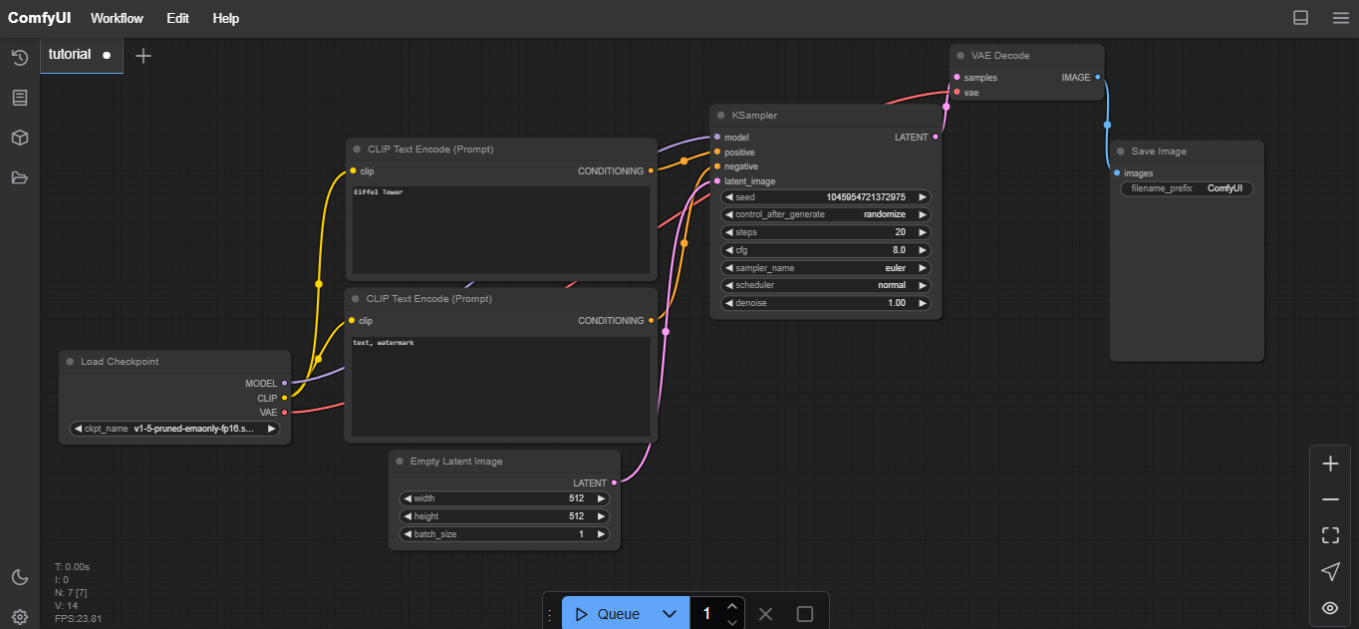

**Overview**

It seems that I was unable to generate a diagram at this time. However, I can provide you with a detailed explanation of the Proposed Solution Diagram for integrating ComfyUI with Stable Diffusion:

**Proposed Solution Diagram Overview:**

1. **User Input (Text Prompt)**
   * You start by entering a text prompt in the ComfyUI interface. This could be anything from "a cyberpunk alleyway" to "a dreamlike underwater world."
2. **ComfyUI Interface**
   * Acting as the central hub, ComfyUI provides an easy-to-use interface where you can tweak settings like model parameters, resolution, and style preferences.
   * It offers options to customize image generation, from adjusting seed values to fine-tuning details.
3. **Customization Options**
   * Want more control? This section lets you refine the image by adjusting parameters like resolution, styles, and input modifications (e.g., tweaking noise levels or blending effects).
4. **Stable Diffusion Model**
   * Once you’ve set everything up, the Stable Diffusion model gets to work.
   * Using advanced AI techniques like denoising and latent space manipulation, it turns your prompt into a visually rich and detailed image.
5. **Advanced Controls (For power users)**
   * Latent space manipulation: Experiment with variations of the generated image.
   * Fine-tuning options: Want a sharper focus or a unique artistic style? Adjust the model settings for a more personalized touch.
6. **Image Output**
   * Once your image is ready, it appears in the ComfyUI display.
   * You can save, download, or further tweak it for your creative projects.
7. **Optimization & Cloud Integration**
   * To make things even smoother, the system can be optimized for faster performance.
   * If your device doesn’t have the required hardware, cloud integration allows you to run the process remotely for real-time results.

**Data Flow**

* Text Input → Sent to ComfyUI, which forwards it to the Stable Diffusion model.
* Customization Options → Adjustments like resolution and style are applied before generation.
* Image Generation → The AI model processes the input and creates the image.
* Final Output → The completed image appears in the UI for download or further tweaks.

**3.2 Requirement Specification**

**3.2.1 Hardware Requirements**

1. **Processor (CPU)**
   * Recommended: Intel Core i7/i9 or AMD Ryzen 7/9 for fast processing.
   * Minimum: Quad-core (Intel i5 or equivalent) for basic performance.
2. **Graphics Card (GPU)**
   * Recommended: NVIDIA RTX 3080 / AMD Radeon RX 6800 or better for fast image generation.
   * Minimum: NVIDIA GTX 1660 (6GB VRAM) for basic functionality.
3. **Memory (RAM)**
   * Recommended: 16GB or more for a lag-free experience.
   * Minimum: 8GB for simple tasks.
4. **Storage**
   * Recommended: 512GB SSD to store models and generated images efficiently.
   * Minimum: 256GB SSD to handle basic operations.
5. **Internet Connection**
   * Required for downloading models and using cloud-based processing.
6. **Cloud Infrastructure (Optional)**
   * Services like AWS, Google Cloud, or Azure can be used for remote processing.

**3.2.2 Software Requirements**

1. **Operating System**
   * Compatible with Windows 10/11, macOS, or Linux (Ubuntu recommended).
2. **Programming Language**
   * Python (v3.8+) is essential for building the solution.
3. **Machine Learning Frameworks**
   * PyTorch (Primary framework for Stable Diffusion)
   * TensorFlow (Optional for extra fine-tuning)
4. **Key Libraries & Dependencies**
   * Diffusers (Manages Stable Diffusion models)
   * Transformers (Handles pre-trained models, e.g., CLIP)
   * TorchVision (For image processing and transformations)
   * Pillow (Image manipulation)
   * OpenCV (Additional image processing features)
   * NumPy (For handling data structures)
5. **User Interface (ComfyUI)**
   * Built on Qt or similar frameworks for a smooth front-end experience.
6. **Web Frameworks (If using a cloud-based UI)**
   * Flask/Django (For creating a web-based interface)
7. **Version Control**
   * Git (For tracking changes and collaboration)
8. **Containerization (Optional for deployment)**
   * Docker (Packages the app into a deployable container)
   * Kubernetes (For cloud scalability, if needed)
9. **Cloud Services (Optional)**
   * Google Cloud, AWS, or Azure for remote processing.
   * High-performance cloud GPUs (NVIDIA A100 or equivalent) for heavy tasks.
10. **Security & Authentication (If multi-user access is required)**

* OAuth2 / JWT for secure login and access management.

**CHAPTER 4**

**Implementation and Result**

* 1. **Snap Shots of Result:**

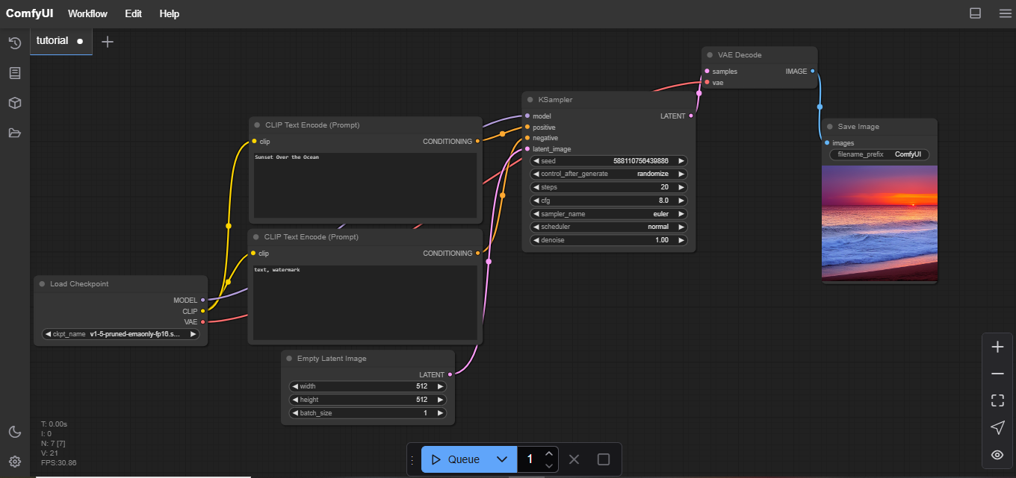

**Fig 1-A Sunset Over the Ocean**

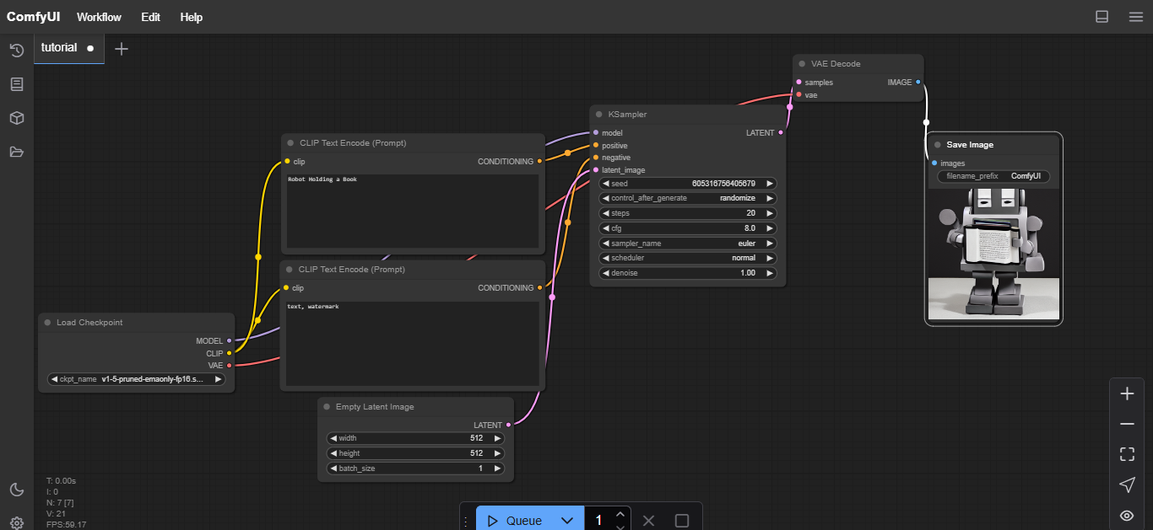

**Fig 2-Robot Holding a Book**

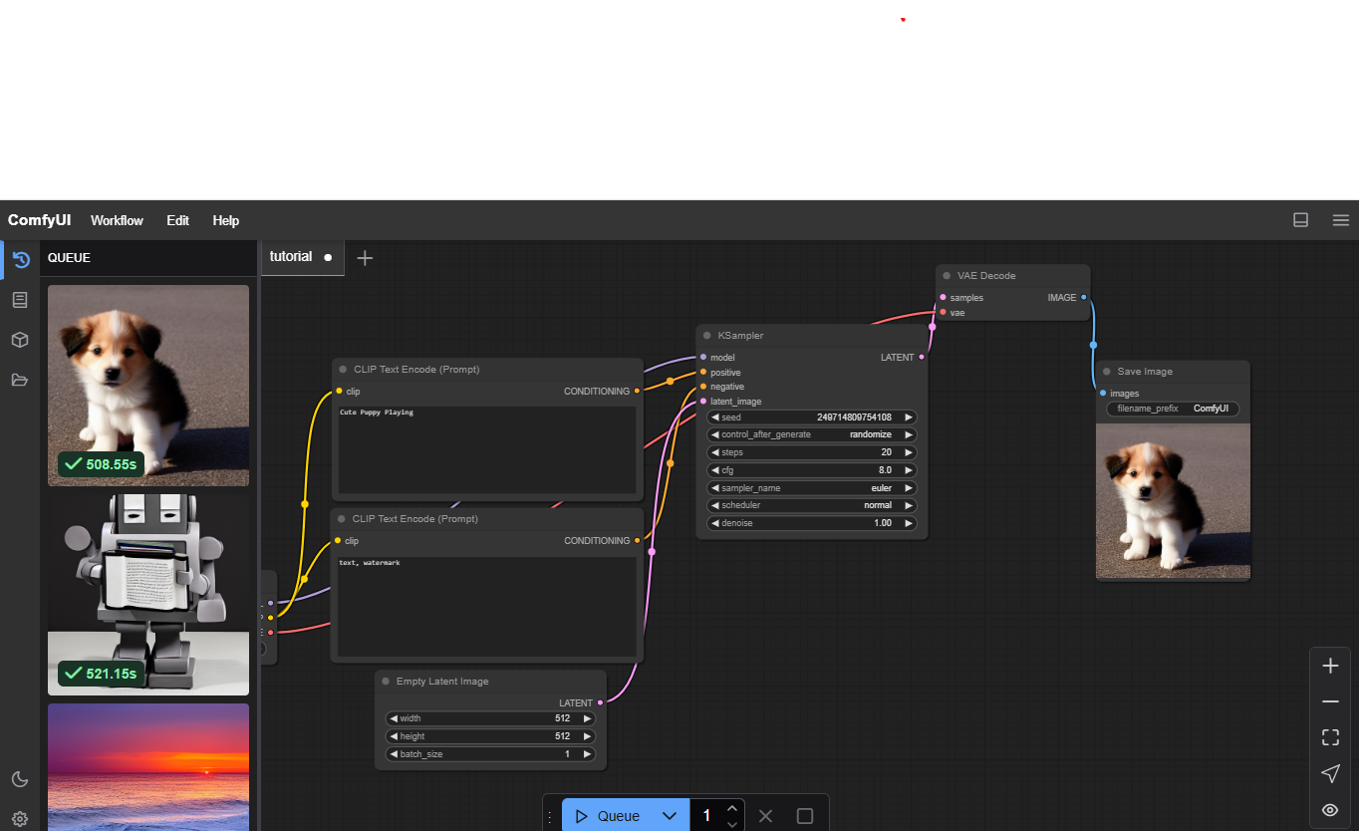

**Fig 3- Cute Puppy Playing**

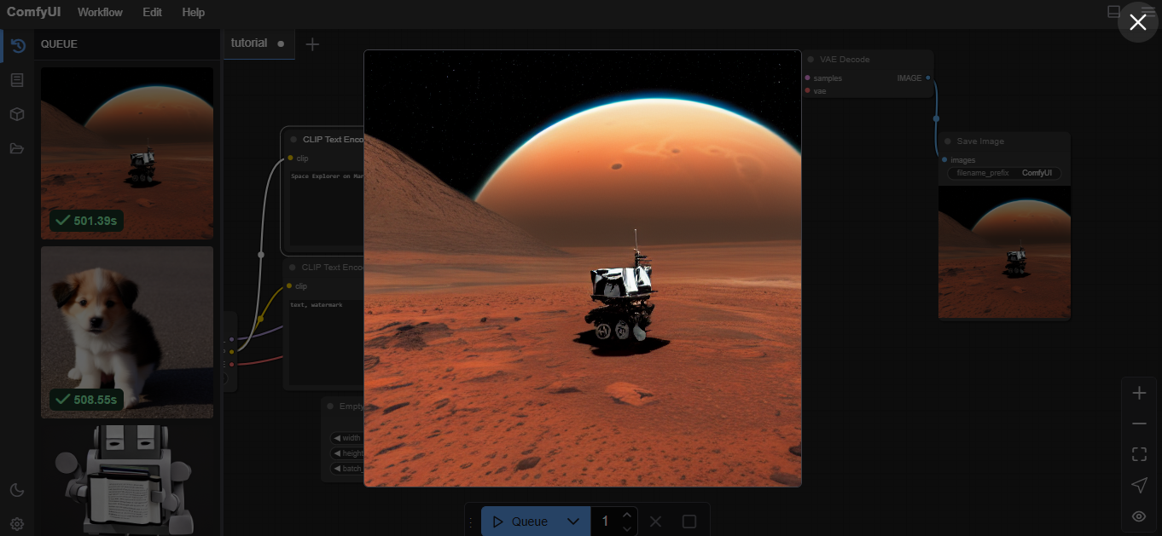

**Fig 4- Space Explorer on Mars**

* 1. **GitHub Link for Code:**

**CHAPTER 5**

**Discussion and Conclusion**

* 1. **Future Work:**
* Development of models capable of generating higher resolution images without loss of detail or quality.
* Integration with other creative tools and platforms (e.g., video editing software, design applications) for a seamless workflow
* Enhanced Comfy UI features that focus on user experience, making it more intuitive and accessible for non-technical learners.
* Advanced capabilities to apply specific artistic styles to generated images, allowing users to create unique and personalized visuals
* . Tools that allow artists and designers to collaborate with AI in generating artwork, leading to new forms of creative expression
  1. **Conclusion:**

The future of image generation with Stable Diffusion and Comfy UI is set to revolutionize creative industries by making advanced image creation more accessible and efficient. As technology evolves, we can anticipate innovations that enhance user experience, elevate image quality, and address ethical concerns. These advancements will redefine how we create, interact with, and integrate AI-generated visuals into various creative workflows.

**REFERENCES**

1. Sumith Kulal, Yannik Marek, Patrick Esser research paper on Stable Diffusion3 model on Scaling Rectified Flow Transformers for High-Resolution Image Synthesis. [Publication: Stability.ai]
2. Flow (Liu et al., 2022; Albergo & Vanden-Eijnden, 2022; Lipman et al., 2023), which connects data and noise on a straight line.